**LAYER 0/Base Layer**

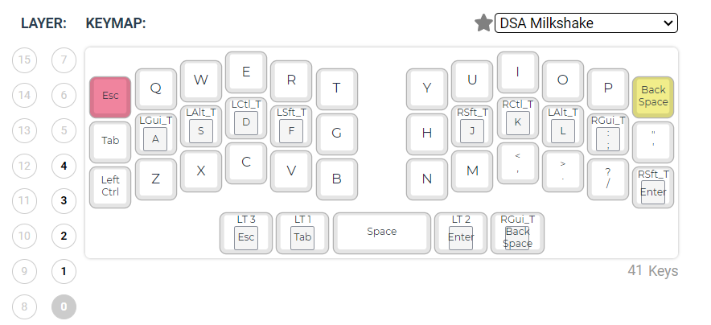

**LAYER 1/LT1/NUMS & Symbols**

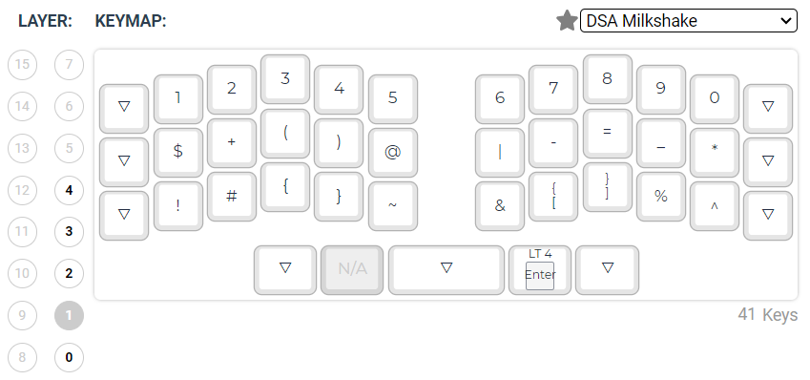

**LAYER 2/LT2/NAV**

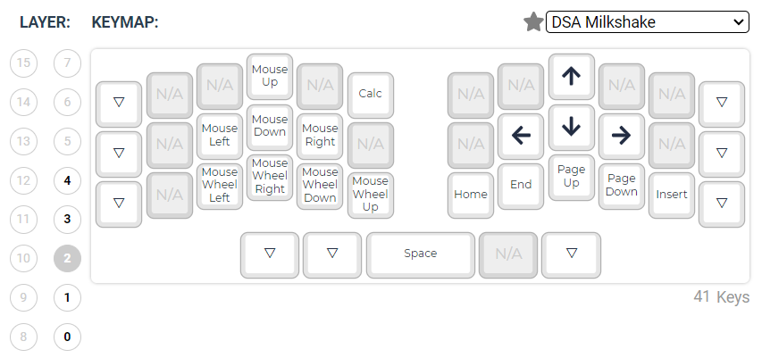

**LAYER 3/LT3/Media Control**

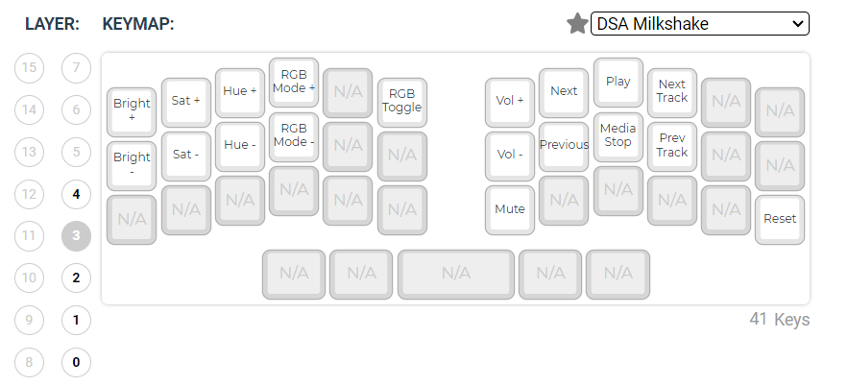

**LAYER 4/LT4/Function**



